Introduction
Ray is a tool for distributed code execution. We can send to Ray code to execute and Ray will choose a node (a computer) from a cluster (set of computers) which has enough resources (CPU, RAM) and will execute this code.
Also different tasks from our code can run simultaneously on different servers.
We have different tools in Ray, for example:
- Ray Core – Basic tool. It is a backbone of other Ray tools.
- Ray Serve – For serving long running Python services that can be accessed via HTTP, gRPC, or directly through Ray APIs.

Ray cluster
Ray cluster consists of:
- Head node
- Worker nodes

Head node’s role
Head node’s role is to:
- Run the GCS (Global Control Store) – It keeps cluster metadata, task scheduling info, actor locations.
- Run Dashboard – Monitoring UI
- Run the global scheduler – It knows resources of nodes (RAM, CPU etc) and using this info it can decide on which node we should run a Worker process which will execute our code.

Processes running on every node
On every node we have the following processes running:
- Raylet
  - Responsible for scheduling, launching and managing tasks/actors on the node where it runs.
- Plasma store
  - It is an object storage
  - It stores results of calculations / large objects. One process can save results here so another one can read them.
  - Tasks don’t pass big objects via network but by reference to plasma memory.
- Worker processes
  - Python worker processes that actually run your task/actor code.
  - They’re started on-demand by the Raylet (not all run all the time).
  - Can be many per node, depending on task concurrency.
The following processes runs only on the Head node:
- GCS (Global Control Store)
  - Cluster metadata, scheduling decisions, resource registry
- Dashboard (optional)
  - UI for monitoring
For more information about how Raylet and Worker processes are used, refer to the ‘Actors’ and ‘Tasks’ sections in this document.

Ray features
For information about Ray features (pros and cons) refer to the ‘ml engineering > model serving > Model serving – tools comparison’ document.

Ray on Kubernetes
Ray can be deployed on Kubernetes. For more information about it please refer to the ‘Ray on Kubernetes’ document in the same folder as this document.

Ray Serve
Ray Serve is a framework for serving long running Python services that can be accessed via HTTP, gRPC, or directly through Ray APIs.
Usually it is used to serve ML models as Rest APIs. For example we can define REST API endpoints using FastAPI, Ray Serve will be running a proxy which will be receiving HTTP requests, and FastAPI will be handling those requests.
We can also expose plain Python functions/classes accessible through Ray APIs.
When we make a request to a Ray Serve endpoint, the corresponding Python code runs on a Ray cluster, in worker processes assigned to actors.

Ray Serve components
Here are described some of the main components in Ray Serve:
- Deployment
- Replica
- Serve Proxy
- Serve Controller

Deployment
Deployment is an object used for running a long-running service, for example a Rest API.
We typically create a Deployment by creating a Python class decorated with @serve.deployment. Its methods can for example specify how to handle HTTP endpoints:
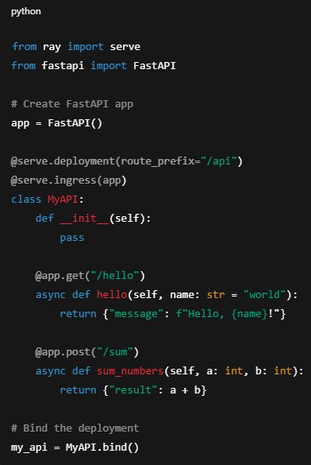
Deployment is a logical definition of the service. We can assign to a deployment specific amount of resources (CPU, GPU).
There is also created a proxy which receives clients requests and forwards them to a proper replica.
Deployment brings additional functionalities to Ray Core Actor, such as:
- Autoscaling and replication – Set up a number of replicas or allow Ray Serve to automatically scale up / down replicas.
- Request routing – Ray Serve Deployment adds a proxy that routes HTTP/gRPS requests or internal calls (using .remote() in our Python code where we created a Deployment) automatically to replicas.
- HTTP/gRPC Ingress - Can expose REST/gRPC endpoints (via route_prefix or FastAPI integration).
- Fault Tolerance & Lifecycle Management - Serve automatically restarts Deployment replicas if they fail.
More info about Ray Core Actors and Worker processes can be found in the ‘Ray Core > Actors’ section in this document.

Replica
For each Deployment Ray Serve creates one or more replicas.
Each replica is a Ray Core Actor (a logical object) and to each Actor there is assigned a Worker process which is executing the code.

Serve Proxy
It is a process (HTTP gateway, Starlette ASGI) which receives requests from clients.

Serve Controller
Serve Controller manages the state and lifecycle of deployments. Here is described what it does:
- Deployment management
- Keeps track of deployments we have defined (names, configs, resources).
- Creates/destroys replicas (actors) according to your configuration or autoscaling.
- Ensures deployments are healthy (restarts replicas if they crash).
- Configuration & API
- Exposes the management API (serve.run, serve.deploy, etc.).
- Routing metadata
- Maintains routing metadata which is used by the Serve Proxy to decide which replica should handle a request

Multiple replicas for one actor
We can assign multiple replicas to one actor, that is one worker process. It is controled using the max_ongoing_requests parameter in the deployment.
If we compare this to running each replica on a separate actor:
- We have more actors so more processes. Server is more burdened.
If we compare this to running one replica on one actor:
- Multiple replicas can receive multiple requests at the same time (each replica is receiving requests at the same time). Those requests are added to a queue and they are waiting there to be executed by the worker process.
- Received requests can be batched and processed together what is sometimes more beneficial (for example making a prediction with ML model for multiple inputs at the same time).
- Received requests can be processed at the same time if they are asynchronous functions.

Multiple deployments
We can create multiple deployments and run them as a single app. This allows us to:
- Assign different resources (CPU, GPU) to each deployment
- Scale each deployment separately depending on a traffic
- Crash in one deployment doesn’t affect others

Running a Deployment
Once we have defined a Deployment, there are multiple ways for how to run it.

Local Python / Ray cluster
When you define a deployment, you need to deploy it into a running Ray cluster, for example:
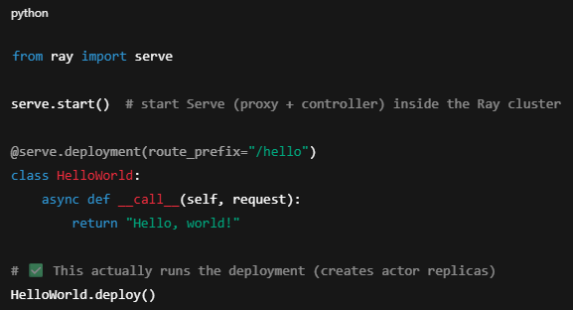
In this case we need to have a Ray cluster running and run this script on one of the cluster’s nodes.
We can also use the serve.run() function which enables creating multiple deployments:
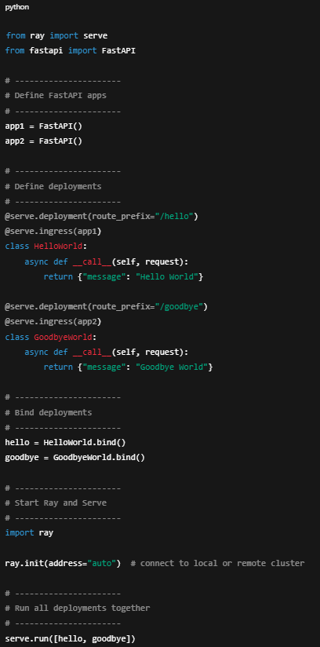

Kubernetes RayService CRD
We can use the Kubernetes RayService CRD to run our deployment. It will start a Ray cluster and run on it our replicas.
In this case we don’t use the .deploy() function in the Python script.

Ray Serve + FastAPI - HTTP requests handling workflow and communication
If we use Ray Serve and FastAPI to create a Rest API app, then workflow looks like this:
- Client sends a HTTP request using a specific endpoint to the Ray Serve’s HTTP gateway (a proxy, Starlette ASGI app).
- Ray Serve’s HTTP gateway parses the request and extracts parameters from it.
- Ray Serve’s HTTP gateway sends the parsed request to an actor (a replica process).
- Inside the Actor, FastAPI chooses a correct route handler (a function assigned to the request’s endpoint).
- If the route has dependencies (e.g., DB sessions, auth checks), FastAPI resolves them here.
- Actor executes the code from the route handler.
- FastAPI serializes the result from the route handler (dict -> JSON).
- Actor sends results back to the Ray Serve’s HTTP Gateway.
- Ray Serve’s HTTP Gateway converts result into a HTTP response and send it back to the client.
For example, we can use Ray with FastAPI to create a Rest API endpoint this way:
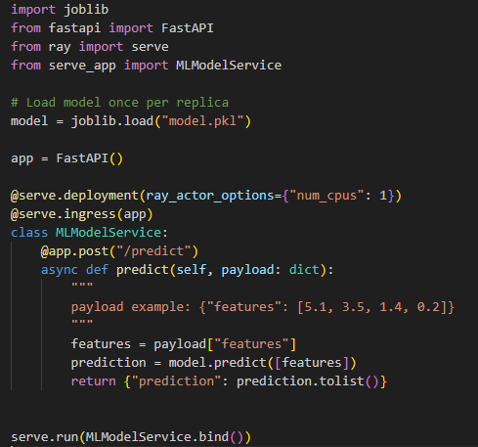

Python functions for monitoring
There are multiple Python functions which allows us to monitor our deployed applications.
For example:
- Ray. serve.status().applications – Show status of deployed applications

Checkpoints
Ray Serve checkpoints maintains a persistent snapshot of deployment state so that:
- The system can recover from failures.
- We can restart the cluster and your deployments come back automatically.
- The operator or serve.status() can show the current deployment state.
Specifically, Ray Serve checkpoints:
- The deployment graph (which deployments exist, their replicas, routes).
- The constructor arguments we pass via .bind() or .deploy().
- The attributes created in __init__ of your deployment object.
- Optional deployment-level configuration (replica resources, autoscaling settings).
Anything created after __init__, such as in a separate method called later, is not checkpointed.
Checkpoints are saved in GCS.
We should avoid checkpointing big objects as there is a disk space limit. We can’t checkpoint more than ~500 MB.
So for example we should not create big attributes in the __init__ method (like a ML model).
Also we should not use in the deployment class any big variables defined outside of this class like here we create a big variable called ‘answer_model’:
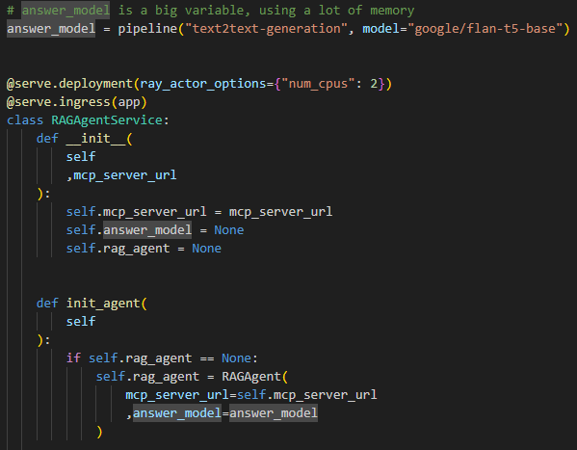
That’s because variables created outside of the class needs to be read when running the deployment class using the .run() method.

Serialization
It is a process of converting an object in memory (for example a Python object, data structures, numpy arrays, ML models) into a byte format that can be:
- Stored (in a file, DB, or memory store), or
- Transmitted (over a network), and
- Later deserialized back into the original object.
Ray uses serialization in order to send data used in a function (from Rest API endpoint) to
another nodes.

Ray Core

Actors
Actor is created based on a Python class. It is a logical object where we have defined calculations.
To every actor there is assigned a worker process which will be executing the code when calling actor’s methods.
Actors are stateful, they contain a state.
For example if our actor is created based on such a class:
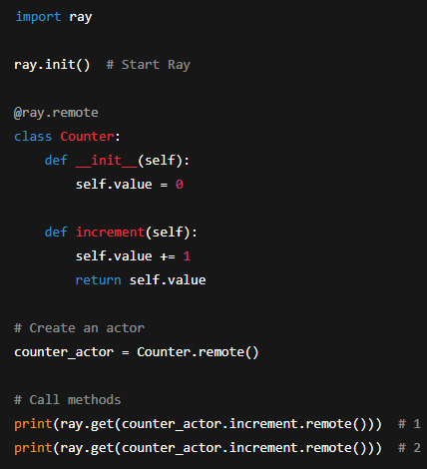
Then self.value is this actor’s state.
We can call actor’s methods multiple times during their life and their state is preserved between calls.

Asynchronous methods call
When we call actor’s method using the .remote() method, then that actor’s method is being executed asynchronously.
That means, that it doesn’t return a result immediately, it runs in a background and it doesn’t block our Python code. After running .remote() method, our Python code goes immediately to the next line of code.
In order to get the actual result of the actor’s method we called used using .remote(), we need to use the ray.get() function, like in the example above.

Processes communication and workflow
Here is described which processes performs which tasks and how they communicate with each other.
When we create an Actor in our code, then:
- Local Raylet (running on the node where we run our code) tries to create on the local node a Worker process which will be assigned to this Actor (it will be running the code when we will call this Actor’s methods).
- If the local node doesn’t have enough resources, then Raylet asks the Cluster Scheduler to find a proper node
- Cluster Scheduler finds a node with enough resources to run the Worker process and talks to the Raylet from this node to run the Worker process.
When we call an Actor’s method in our code, then:
- We talk to the local Raylet (running on the same node where we run our code)
- If this Raylet is not the one managing this Actor, then it forwards the task (of executing the Actor’s method) to the Raylet from another node which does manage this Actor (each Raylet uses GCS to find out which Raylets manages which Actors)
- Raylet managing the Actor forwards the task to the Worker process assigned to this Actor. This Worker process runs on the same node as the Raylet.
- Worker process executes the task
Important features of the Raylet:
- Each Raylet uses GCS to find out which Raylets manages which Actors. In GCS there is metadata about it.
- Raylet which manages an Actor sends to the Worker process assigned to this Actor tasks of executing the code
- Raylet sends tasks only to Worker processes running on the same node as the Raylet
Important features of Worker processes assigned to Actors:
- They are long running processes, they run until we kill them.
- They execute code when we will call this Actor’s methods.
- They receive tasks to execute from the local Raylet running on the same node.
- Each Actor has assigned a single Worker process.

Tasks
Ray task is a stateless function. When we call it, it gets executed and it finishes.
For example we can create a Task like this:
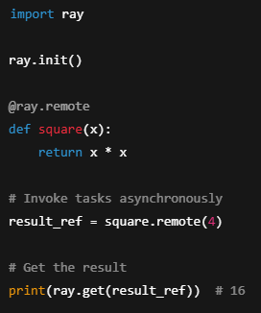

Asynchronous task call
The .remote() function is asynchronous. So when we run it, it doesn’t block a Python script, further lines in code are being executed immediately without waiting for the .remote() to be finished.
The result_ref variable in the above example is not the output of the square function. We need to use ray.get(result_ref) to get that result.

Distributed and parallel execution
When we run a single task multiple times by calling .remote(), or when we run multiple tasks, then:
- All those tasks’ calls run in parallel
- Ray can run different tasks calls on different servers
Benefits:
- Parallel task execution
- Distribution of taks across multiple servers

Processes communication and workflow
When we run a task (using .remote()), then:
- Local Raylet (running on the same host where we run the task) tries to find a Worker process running on the same node as the Raylet which can execute the task.
- If there is no existing Worker process available for this task, then Raylet tries to create a new one (on the same node as the Raylet is running on).
- If the node where this Raylet is running on doesn’t have enough resources for creating a new Worker process, then Raylet asks the Cluster Scheduler to find a proper node.
- Cluster Scheduler finds a node with enough resources and talks to the Raylet running on this node to start the Worker proces.
- After executing the task, the Worker process becomes idle and can be reused for the future tasks.
Important features of the Raylet process:
- Raylet can run a Worker process only on the same host where Raylet is running.
Important features of the Worker process:
- It is not tied to one Task. Each Worker process can execute any task.

